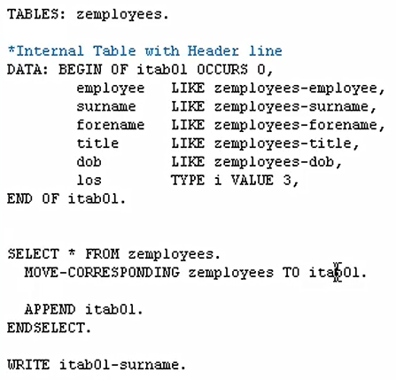

We have the MOVE statement, and we have dash. And we specify the table name, which is our zemployees table, and we just say we want to move it to our itab table.

And all you need to make sure is that the fields that you're hoping to move are named the same between the two tables. There is one thing to watch out for, and that's when you use this statement, just ensure that the fields you are moving data to and from do have the same data type or length.